Location: Wilkinson building, level 3, study space (306 room)

My friends and I left from Wilkinson building at 14:33 and came back at 15:16 in April 26.

During this time, my friend's bag was lost, my backpack was rummaged and my wallet was lost.

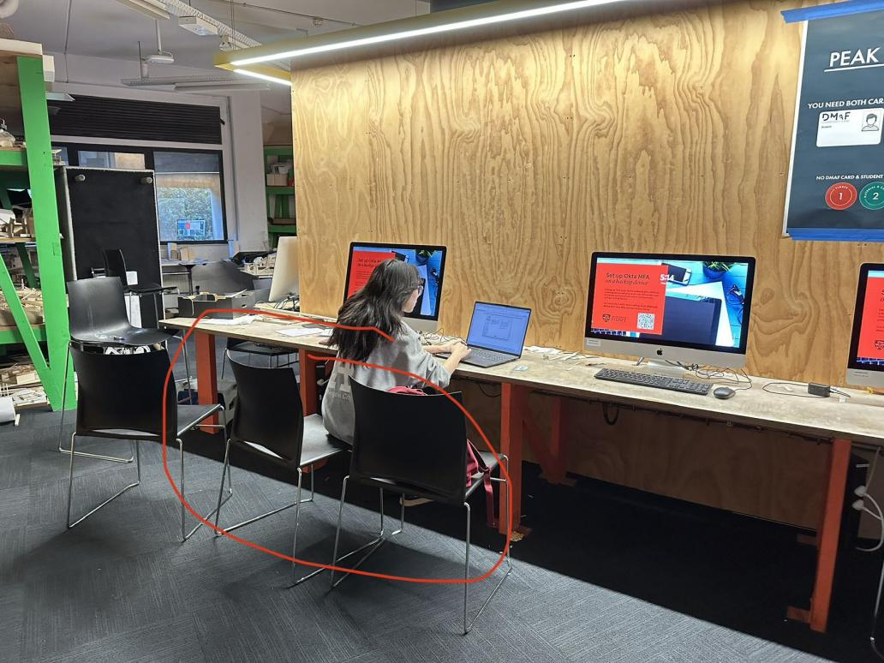

Put the bag in this highlighted position

We went to the student center and the service building for help. Then returned to the Wilkinson building and found my friend's backpack behind lockers, which also showed signs of rummaging.

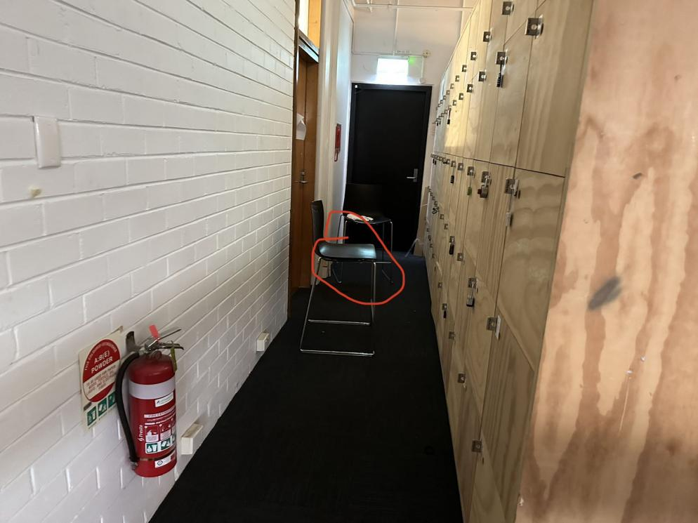

Find my friend’s bag on this chair

In the end, my wallet was still missing.

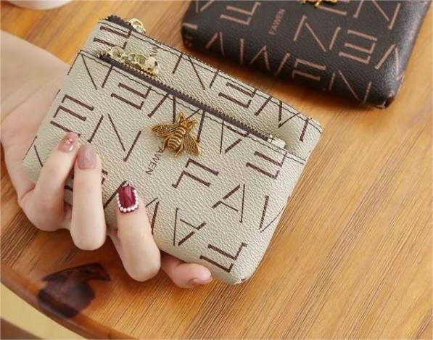

My wallet